Image Database for Everyday Affective Spaces (IDEAS)
2025-07-11
This script reproduces all statistical analyses, tables, and figures in the IDEAS study. Please cite the article [REMOVED FOR REVIEW] if you make use of this code.

Start

3. Results - Descriptive Statistics

Intraclass Correlation Coefficient
ICC Score for each dependent variable
Response | ICC Value | Lower Bound | Upper Bound
Valence | 0.876 | 0.867 | 0.885
Approach-avoidance | 0.871 | 0.861 | 0.88
Tense Arousal | 0.878 | 0.869 | 0.887
Energetic Arousal | 0.888 | 0.88 | 0.896

Descriptive Statistics
Descriptive statistics for study variables.
Variable | Mean | SD
Valence | 0.569 | 0.88
Energetic arousal | 0.667 | 0.92
Tense arousal | -0.660 | 0.93
Approach-avoidance | 0.565 | 0.92

Correlation Table
Correlation Matrix
 | valence | tense | energetic | approach
valence | 1.00 | -0.73 | 0.07 | 0.98
tense | -0.73 | 1.00 | 0.32 | -0.72
energetic | 0.07 | 0.32 | 1.00 | 0.08
approach | 0.98 | -0.72 | 0.08 | 1.00

3.1 Reliability and Validation of IDEAS

Equivalence Test

Valence
## Estimate Std. Error df t value lower upper Pr(>|t|)
## 1 0.5013552 0.1693542 1488.072 8.865177 0.1691568 0.8335536 2.135507e-18
## Estimate Std. Error df t value lower upper Pr(>|t|)
## 1 0.5013552 0.1693542 1488.072 -2.944389 0.1691568 0.8335536 0.003286145

Tense Arousal
## Estimate Std. Error df t value lower upper Pr(>|t|)
## 1 -0.06064802 0.1938829 1589.032 4.844944 -0.4409413 0.3196452 1.38999e-06
## Estimate Std. Error df t value lower upper Pr(>|t|)
## 1 -0.06064802 0.1938829 1589.032 -5.470559 -0.4409413 0.3196452 5.203711e-08

Energetic Arousal
## Estimate Std. Error df t value lower upper Pr(>|t|)
## 1 1.70682 0.185815 1906.424 14.56728 1.342397 2.071242 1.170594e-45
## Estimate Std. Error df t value lower upper Pr(>|t|)
## 1 1.70682 0.185815 1906.424 3.803888 1.342397 2.071242 0.0001469296

Approach-avoidance
## Estimate Std. Error df t value lower upper Pr(>|t|)
## 1 0.4130747 0.1772155 1522.454 7.973764 0.06546231 0.7606871 2.996449e-15
## Estimate Std. Error df t value lower upper Pr(>|t|)
## 1 0.4130747 0.1772155 1522.454 -3.31193 0.06546231 0.7606871 0.0009482578
Residual skewness and kurtosis for each model
Outcome | Skewness | Kurtosis
Valence | -0.10 | 3.48
Approach_Avoidance | -0.14 | 3.53
Tense_Arousal | -0.07 | 2.91
Energetic_Arousal | -0.69 | 3.20

Fixed Effects from Linear Mixed Models
Dependent.Variable | Full.Model | Numerator.DF | Denominator.DF | F | p | Partial.EtaSquared
Valence | study | 1 | 1488 | 8.76** | 0.00 | 0.01
 | image | 8 | 3664 | 676.85*** | 0.00 | 0.60
Approach-avoidance | study | 1 | 1522 | 5.43* | 0.02 | 0.00
 | image | 8 | 3663 | 671.64*** | 0.00 | 0.59
Tense Arousal | study | 1 | 1589 | 0.10 | 0.75 | 0.00
 | image | 8 | 3683 | 415.75*** | 0.00 | 0.47
Energetic Arousal | study | 1 | 1906 | 84.37*** | 0.00 | 0.04
 | image | 8 | 3675 | 53.30*** | 0.00 | 0.10

3.2 Examining the Relationship Between Affective Responses

Building Models for all dependent variables

Table 4.
Table 1: Model Comparison Table
 | Model 1 Independence |  |  | Model 2 Linear Relation |  |  | Model 3 Symmetric V |  |  | Model 4 Asymmetric V positivity offset |  |  | Model 5 Asymmetric V negativity bias |  |  | Model 6 Asymmetric V positivity offset + negativity bias |  |  | Model 7 Nonparametric
Relationship | BIC | R2 | PP | BIC | R2 | PP | BIC | R2 | PP | BIC | R2 | PP | BIC | R2 | PP | BIC | R2 | PP | BIC | R2 | PP
Tense - Valence | 4856 | 0 | 0 | 3516 | 0.53 | 0.00 | 4669 | 0.10 | 0.00 | 4027 | 0.37 | 0.00 | 3468 | 0.54 | 0.96 | 3474 | 0.54 | 0.04 | 3481 | 0.54 | 0
Valence - Tense | 4653 | 0 | 0 | 3313 | 0.53 | 0.92 | 4459 | 0.11 | 0.00 | 3746 | 0.40 | 0.00 | 3318 | 0.53 | 0.08 | 3324 | 0.53 | 0.00 | 3329 | 0.53 | 0
Energetic-Valence | 4823 | 0 | 0 | 4821 | 0.01 | 0.00 | 4795 | 0.02 | 0.95 | 4803 | 0.02 | 0.02 | 4803 | 0.02 | 0.02 | 4810 | 0.02 | 0.00 | 4821 | 0.03 | 0
Valence-Energetic | 4653 | 0 | 0 | 4651 | 0.01 | 0.00 | 4619 | 0.02 | 0.94 | 4625 | 0.02 | 0.03 | 4626 | 0.02 | 0.03 | 4633 | 0.02 | 0.00 | 4637 | 0.03 | 0
Tense-Energetic | 4856 | 0 | 0 | 4665 | 0.10 | 0.00 | 4863 | 0.00 | 0.00 | 4666 | 0.11 | 0.00 | 4629 | 0.13 | 0.00 | 4633 | 0.13 | 0.00 | 4607 | 0.15 | 1
Energetic-Tense | 4823 | 0 | 0 | 4632 | 0.10 | 0.00 | 4686 | 0.08 | 0.00 | 4661 | 0.09 | 0.00 | 4600 | 0.12 | 0.00 | 4592 | 0.13 | 0.00 | 4561 | 0.15 | 1

Figure 3
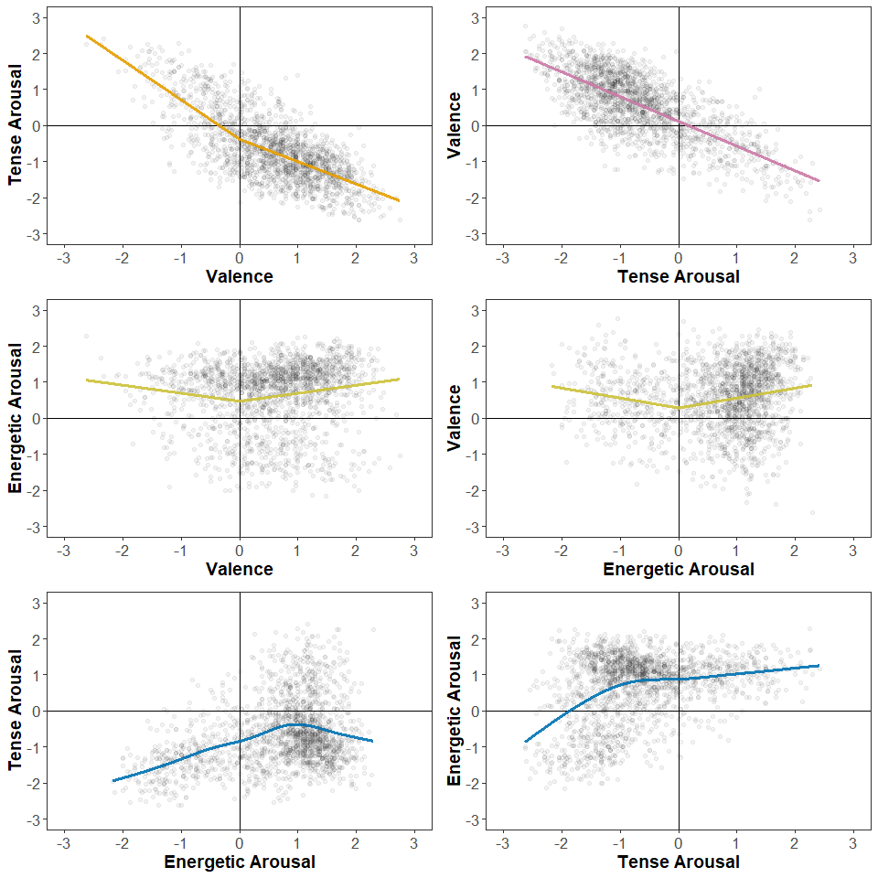 #### Figure 3 Supplementary
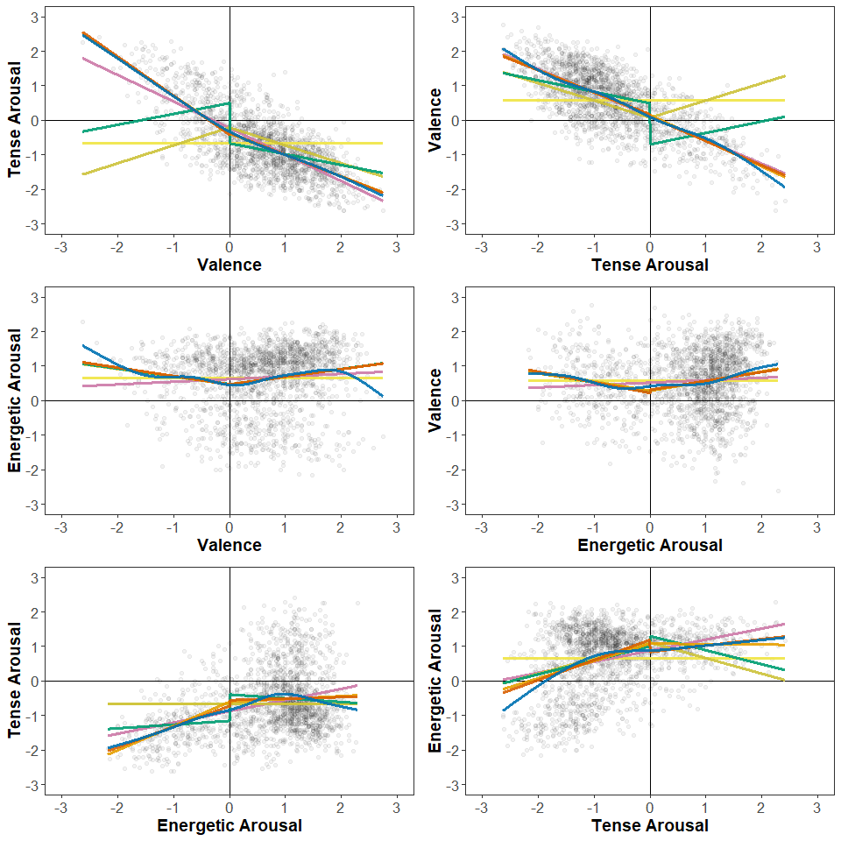

Table 5
Response | Standardized Coefficients | SE | p | 95% CI
valence | 0.96 | 0.01 | < .001*** | [0.99, 1.03]
tense | -0.02 | 0.01 | .012* | [-0.03, -0.00]
energetic | 0.02 | 0.01 | .008** | [0.00, 0.03]
valence:tense | -0.02 | 0.00 | .003** | [-0.02, -0.00]
valence:energetic | -0.00 | 0.01 | .548 | [-0.01, 0.01]

3.2 Effect of Demographic Variables on Affective and Approach-avoidance responses
Residual skewness and kurtosis for each model
Outcome | Skewness | Kurtosis
Valence | -0.36 | 2.92
Approach_Avoidance | -0.35 | 2.78
Tense_Arousal | 0.51 | 2.85
Energetic_Arousal | -0.67 | 3.06

Table 6
Marginal and Conditional R-squared values for each outcome
Dependent Variable | R2 Marginal | R2 Conditional
Valence | 0.06 | 0.23
Tense_Arousal | 0.04 | 0.20
Energetic_Arousal | 0.03 | 0.14
Approach_Avoidance | 0.05 | 0.23

Table 7
Ethnicity had a statistically significant effect on valence and tense arousal (F(4,402) = 5.73, p < 0.005) ratings (Table 6). In addition, sex had a statistically significant effect of valence ratings (F(1,393) = 6.86, p < 0.01). Estimated marginal means showed that participants who identified as Black (M = 5.14, SE = 0.25) rated images as more pleasant than participants who identified as White (M = 4.4, SE = 0.21). In addition, participants who identified as Black (M = 3.23, SE = 0.3) rated the presented scenes as less tense than participants who identified as White (M = 3.79, SE = 0.27) and Mixed (M = 3.71, SE = 0.32). Lastly, participants who identified as female (M = 4.39, SE = 0.13) rated images as less pleasant than participants who identified as male (M = 4.59, SE = 0.13).
Fixed Effects from Linear Mixed Models
Dependent.Variable | Full.Model | Numerator.DF | Denominator.DF | F | p | Partial.EtaSquared
Valence | Country.of.residence | 32 | 398 | 0.83 | 0.74 | 0.06
 | Ethnicity.simplified | 4 | 398 | 7.36*** | 0.00 | 0.07
 | Sex | 2 | 398 | 3.69* | 0.03 | 0.02
 | Age | 1 | 398 | 0.44 | 0.51 | 0.00
 | Employment.status | 6 | 399 | 1.64 | 0.14 | 0.02
Approach-avoidance | Country.of.residence | 32 | 398 | 0.80 | 0.78 | 0.06
 | Ethnicity.simplified | 4 | 398 | 6.36*** | 0.00 | 0.06
 | Sex | 2 | 398 | 1.60 | 0.20 | 0.01
 | Age | 1 | 398 | 0.08 | 0.78 | 0.00
 | Employment.status | 6 | 399 | 1.44 | 0.20 | 0.02
Tense Arousal | Country.of.residence | 29 | 401 | 0.72 | 0.85 | 0.05
 | Ethnicity.simplified | 4 | 400 | 5.58*** | 0.00 | 0.05
 | Sex | 2 | 400 | 0.69 | 0.50 | 0.00
 | Age | 1 | 400 | 1.17 | 0.28 | 0.00
 | Employment.status | 6 | 400 | 0.59 | 0.74 | 0.01
Energetic Arousal | Country.of.residence | 29 | 401 | 0.90 | 0.62 | 0.06
 | Ethnicity.simplified | 4 | 400 | 1.98 | 0.10 | 0.02
 | Sex | 2 | 400 | 0.71 | 0.49 | 0.00
 | Age | 1 | 400 | 0.97 | 0.32 | 0.00
 | Employment.status | 6 | 400 | 0.96 | 0.45 | 0.01

Figure 1
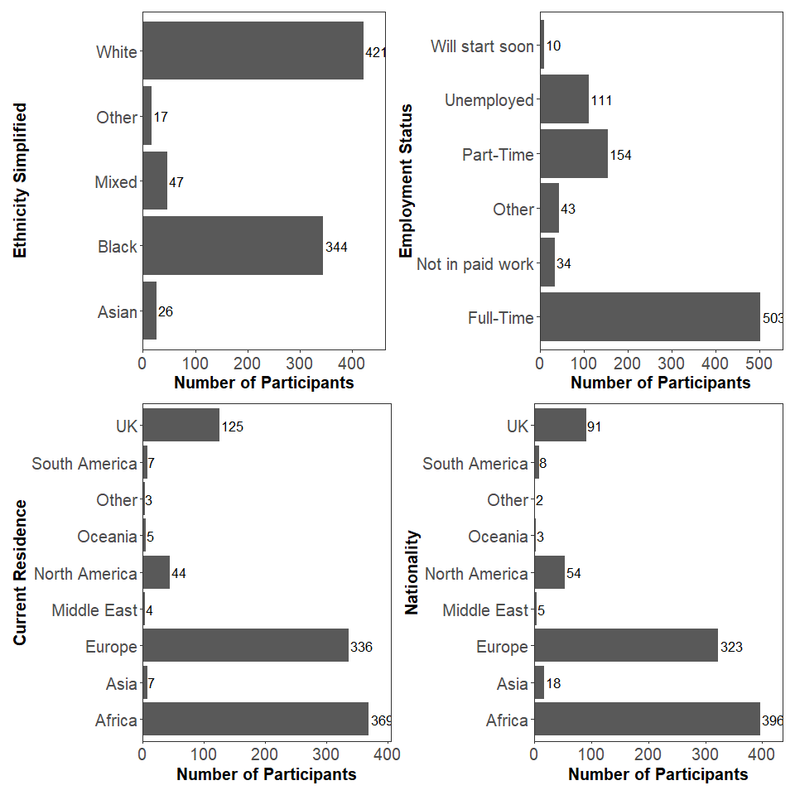

3.3 Room Type
Levene Test Room Type
 | DV | Levene_F | Levene_p | Shapiro_W | Shapiro_p
W | valence | 6.301847 | 0.0000083 | 0.9960752 | 0.0001291
W1 | approach | 6.074146 | 0.0000138 | 0.9961043 | 0.0001390
W2 | tense | 3.901889 | 0.0016046 | 0.9841252 | 0.0000000
W3 | energetic | 15.345863 | 0.0000000 | 0.9959626 | 0.0000974

Welch’s ANOVA results
Dependent Variable | Numerator DF | Denominator DF | F | p
Valence | 5 | 835.93 | 133.51 | 0
Appraoch-avoidance | 5 | 835.89 | 138.31 | 0
Tense Arousal | 5 | 835.94 | 340.90 | 0
Energetic Arousal | 5 | 834.27 | 993.43 | 0

Estimated marginal means (M) and standard errors (SE) by room type
Outcome | Room Type | Mean (M) | SE
Valence | bedroom | 0.46 | 0.04
Valence | dining room | 0.72 | 0.04
Valence | kitchen | 0.87 | 0.04
Valence | living room | 0.81 | 0.04
Valence | office | -0.38 | 0.04
Valence | restaurant | 0.93 | 0.04
Tense Arousal | bedroom | -1.29 | 0.04
Tense Arousal | dining room | -0.77 | 0.04
Tense Arousal | kitchen | -0.77 | 0.04
Tense Arousal | living room | -1.18 | 0.04
Tense Arousal | office | 0.77 | 0.04
Tense Arousal | restaurant | -0.73 | 0.04
Energetic Arousal | bedroom | -0.98 | 0.03
Energetic Arousal | dining room | 1.03 | 0.03
Energetic Arousal | kitchen | 1.21 | 0.03
Energetic Arousal | living room | 0.29 | 0.03
Energetic Arousal | office | 1.16 | 0.03
Energetic Arousal | restaurant | 1.29 | 0.03

Figure 4
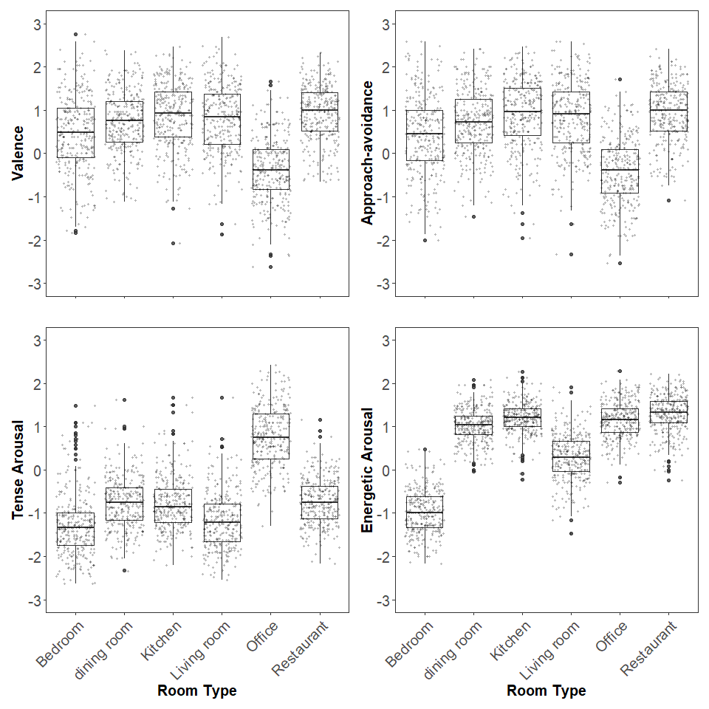

Appendix

Results of all regression models created in the study

Results Regression TfV
Model 2 TfV:
Response | Standardized Coefficients | SE | p | 95% CI
valence | -0.73 | 0.02 | < .001*** | [-0.80, -0.73]
Model 3 TfV:
Response | Standardized Coefficients | SE | p | 95% CI
abs(valence) | -0.32 | 0.04 | < .001*** | [-0.59, -0.45]
Model 4 TfV:
Response | Standardized Coefficients | SE | p | 95% CI
abs(valence) | -0.19 | 0.03 | < .001*** | [-0.37, -0.25]
I_valence | -0.54 | 0.04 | < .001*** | [-1.25, -1.08]
Model 5 TfV:
Response | Standardized Coefficients | SE | p | 95% CI
abs(valence) | 0.68 | 0.05 | < .001*** | [1.00, 1.19]
abs(valence):I_valence | -1.20 | 0.04 | < .001*** | [-1.80, -1.63]
Model 6 TfV:
Response | Standardized Coefficients | SE | p | 95% CI
abs(valence) | 0.70 | 0.06 | < .001*** | [1.01, 1.25]
I_valence | 0.03 | 0.06 | .348 | [-0.06, 0.17]
abs(valence):I_valence | -1.23 | 0.07 | < .001*** | [-1.90, -1.63]

Results Regression VfT
Model 2 VfT:
Response | Standardized Coefficients | SE | p | 95% CI
tense | -0.73 | 0.02 | < .001*** | [-0.72, -0.66]
Model 3 VfT:
Response | Standardized Coefficients | SE | p | 95% CI
abs(tense) | 0.33 | 0.03 | < .001*** | [0.43, 0.57]
Model 4 VfT:
Response | Standardized Coefficients | SE | p | 95% CI
abs(tense) | 0.22 | 0.03 | < .001*** | [0.28, 0.39]
I_tense | -0.55 | 0.04 | < .001*** | [-1.27, -1.11]
Model 5 VfT:
Response | Standardized Coefficients | SE | p | 95% CI
abs(tense) | 0.42 | 0.03 | < .001*** | [0.60, 0.70]
abs(tense):I_tense | -0.66 | 0.03 | < .001*** | [-1.47, -1.33]
Model 6 VfT:
Response | Standardized Coefficients | SE | p | 95% CI
abs(tense) | 0.41 | 0.03 | < .001*** | [0.58, 0.69]
I_tense | -0.04 | 0.06 | .224 | [-0.20, 0.05]
abs(tense):I_tense | -0.63 | 0.06 | < .001*** | [-1.46, -1.22]

Results Regression Efv
Model 2 Efv:
Response | Standardized Coefficients | SE | p | 95% CI
valence | 0.07 | 0.02 | .002** | [0.03, 0.13]
Model 3 Efv:
Response | Standardized Coefficients | SE | p | 95% CI
abs(valence) | 0.14 | 0.04 | < .001*** | [0.15, 0.30]
Model 4 Efv:
Response | Standardized Coefficients | SE | p | 95% CI
abs(valence) | 0.14 | 0.04 | < .001*** | [0.15, 0.30]
I_valence | -0.01 | 0.05 | .784 | [-0.12, 0.09]
Model 5 Efv:
Response | Standardized Coefficients | SE | p | 95% CI
abs(valence) | 0.15 | 0.07 | < .001*** | [0.11, 0.38]
abs(valence):I_valence | -0.02 | 0.06 | .718 | [-0.14, 0.10]
Model 6 Efv:
Response | Standardized Coefficients | SE | p | 95% CI
abs(valence) | 0.15 | 0.09 | .007** | [0.07, 0.42]
I_valence | 0.00 | 0.09 | .980 | [-0.17, 0.17]
abs(valence):I_valence | -0.02 | 0.10 | .813 | [-0.22, 0.17]

Results Regression VfE
Model 2 VfE:
Response | Standardized Coefficients | SE | p | 95% CI
energetic | 0.07 | 0.02 | .002** | [0.03, 0.11]
Model 3 VfE:
Response | Standardized Coefficients | SE | p | 95% CI
abs(energetic) | 0.15 | 0.04 | < .001*** | [0.19, 0.36]
Model 4 VfE:
Response | Standardized Coefficients | SE | p | 95% CI
abs(energetic) | 0.15 | 0.04 | < .001*** | [0.19, 0.35]
I_energetic | 0.02 | 0.05 | .372 | [-0.05, 0.15]
Model 5 VfE:
Response | Standardized Coefficients | SE | p | 95% CI
abs(energetic) | 0.14 | 0.06 | < .001*** | [0.13, 0.37]
abs(energetic):I_energetic | 0.02 | 0.05 | .589 | [-0.07, 0.12]
Model 6 VfE:
Response | Standardized Coefficients | SE | p | 95% CI
abs(energetic) | 0.17 | 0.09 | < .001*** | [0.14, 0.48]
I_energetic | 0.04 | 0.11 | .385 | [-0.12, 0.30]
abs(energetic):I_energetic | -0.03 | 0.10 | .617 | [-0.25, 0.15]

Results Regression EfT
Model 2 EfT:
Response | Standardized Coefficients | SE | p | 95% CI
tense | 0.32 | 0.02 | < .001*** | [0.28, 0.36]
Model 3 EfT:
Response | Standardized Coefficients | SE | p | 95% CI
abs(tense) | -0.28 | 0.04 | < .001*** | [-0.52, -0.38]
Model 4 EfT:
Response | Standardized Coefficients | SE | p | 95% CI
abs(tense) | -0.25 | 0.04 | < .001*** | [-0.48, -0.34]
I_tense | 0.13 | 0.05 | < .001*** | [0.19, 0.39]
Model 5 VfT:
Response | Standardized Coefficients | SE | p | 95% CI
abs(tense) | -0.31 | 0.04 | < .001*** | [-0.57, -0.43]
abs(tense):I_tense | 0.22 | 0.05 | < .001*** | [0.39, 0.59]
Model 6 EfT:
Response | Standardized Coefficients | SE | p | 95% CI
abs(tense) | -0.36 | 0.04 | < .001*** | [-0.66, -0.50]
I_tense | -0.15 | 0.09 | < .001*** | [-0.52, -0.17]
abs(tense):I_tense | 0.34 | 0.09 | < .001*** | [0.60, 0.94]

Results Regression TfE
Model 2 TfE:
Response | Standardized Coefficients | SE | p | 95% CI
energetic | 0.32 | 0.02 | < .001*** | [0.28, 0.37]
Model 3 VfT:
Response | Standardized Coefficients | SE | p | 95% CI
abs(energetic) | -0.00 | 0.05 | .887 | [-0.10, 0.08]
Model 4 TfE:
Response | Standardized Coefficients | SE | p | 95% CI
abs(energetic) | -0.06 | 0.04 | .013* | [-0.19, -0.02]
I_energetic | 0.33 | 0.05 | < .001*** | [0.66, 0.86]
Model 5 TfE:
Response | Standardized Coefficients | SE | p | 95% CI
abs(energetic) | -0.37 | 0.06 | < .001*** | [-0.82, -0.58]
abs(energetic):I_energetic | 0.51 | 0.05 | < .001*** | [0.69, 0.88]
Model 6 TfE:
Response | Standardized Coefficients | SE | p | 95% CI
abs(energetic) | -0.31 | 0.09 | < .001*** | [-0.77, -0.42]
I_energetic | 0.08 | 0.11 | .104 | [-0.04, 0.38]
abs(energetic):I_energetic | 0.41 | 0.10 | < .001*** | [0.44, 0.84]

Pairwise comparisons for each room type

Valence Pairwise Comparison Room Type
contrast | estimate | SE | df | t | p
bedroom - dining room | -0.26 | 0.06 | 1,794 | -4.27 | < .001***
bedroom - kitchen | -0.41 | 0.06 | 1,794 | -6.70 | < .001***
bedroom - living room | -0.34 | 0.06 | 1,794 | -5.59 | < .001***
bedroom - office | 0.84 | 0.06 | 1,794 | 13.68 | < .001***
bedroom - restaurant | -0.47 | 0.06 | 1,794 | -7.60 | < .001***
dining room - kitchen | -0.15 | 0.06 | 1,794 | -2.43 | .145
dining room - living room | -0.08 | 0.06 | 1,794 | -1.32 | .774
dining room - office | 1.11 | 0.06 | 1,794 | 17.95 | < .001***
dining room - restaurant | -0.21 | 0.06 | 1,794 | -3.33 | .011*
kitchen - living room | 0.07 | 0.06 | 1,794 | 1.12 | .875
kitchen - office | 1.26 | 0.06 | 1,794 | 20.38 | < .001***
kitchen - restaurant | -0.06 | 0.06 | 1,794 | -0.89 | .948
living room - office | 1.19 | 0.06 | 1,794 | 19.26 | < .001***
living room - restaurant | -0.12 | 0.06 | 1,794 | -2.01 | .338
office - restaurant | -1.31 | 0.06 | 1,794 | -21.27 | < .001***

Tense Arousal Pairwise Comparison Room Type
contrast | estimate | SE | df | t | p
bedroom - dining room | -0.52 | 0.05 | 1,794 | -10.03 | < .001***
bedroom - kitchen | -0.52 | 0.05 | 1,794 | -9.94 | < .001***
bedroom - living room | -0.11 | 0.05 | 1,794 | -2.13 | .274
bedroom - office | -2.06 | 0.05 | 1,794 | -39.48 | < .001***
bedroom - restaurant | -0.56 | 0.05 | 1,794 | -10.73 | < .001***
dining room - kitchen | 0.00 | 0.05 | 1,794 | 0.08 | 1.00
dining room - living room | 0.41 | 0.05 | 1,794 | 7.90 | < .001***
dining room - office | -1.54 | 0.05 | 1,794 | -29.45 | < .001***
dining room - restaurant | -0.04 | 0.05 | 1,794 | -0.70 | .982
kitchen - living room | 0.41 | 0.05 | 1,794 | 7.82 | < .001***
kitchen - office | -1.54 | 0.05 | 1,794 | -29.54 | < .001***
kitchen - restaurant | -0.04 | 0.05 | 1,794 | -0.78 | .971
living room - office | -1.95 | 0.05 | 1,794 | -37.36 | < .001***
living room - restaurant | -0.45 | 0.05 | 1,794 | -8.60 | < .001***
office - restaurant | 1.50 | 0.05 | 1,794 | 28.76 | < .001***

Energetic Arousal Pairwise Comparison Room Type
contrast | estimate | SE | df | t | p
bedroom - dining room | -2.00 | 0.04 | 1,794 | -55.19 | < .001***
bedroom - kitchen | -2.18 | 0.04 | 1,794 | -60.19 | < .001***
bedroom - living room | -1.26 | 0.04 | 1,794 | -34.84 | < .001***
bedroom - office | -2.14 | 0.04 | 1,794 | -58.91 | < .001***
bedroom - restaurant | -2.27 | 0.04 | 1,794 | -62.55 | < .001***
dining room - kitchen | -0.18 | 0.04 | 1,794 | -4.99 | < .001***
dining room - living room | 0.74 | 0.04 | 1,794 | 20.35 | < .001***
dining room - office | -0.13 | 0.04 | 1,794 | -3.72 | .003**
dining room - restaurant | -0.27 | 0.04 | 1,794 | -7.36 | < .001***
kitchen - living room | 0.92 | 0.04 | 1,794 | 25.34 | < .001***
kitchen - office | 0.05 | 0.04 | 1,794 | 1.28 | .797
kitchen - restaurant | -0.09 | 0.04 | 1,794 | -2.36 | .170
living room - office | -0.87 | 0.04 | 1,794 | -24.06 | < .001***
living room - restaurant | -1.00 | 0.04 | 1,794 | -27.70 | < .001***
office - restaurant | -0.13 | 0.04 | 1,794 | -3.64 | .004**

